- 下载缺失文件
执行./build/prebuilts download.sh
查看缺失的文件，一共7个，developtools_ace_ets2bundle，developtools_ace_js2bundle，/third_party_jsframework，third_party_parse5，third_party_weex-loader，arkcompiler_ets_frontend，interface_sdk-js
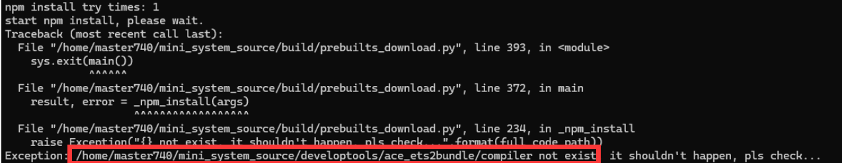
例1

到OpenHarmony - Open_Harmony - Gitee.com查找文件（可跳过）
查看自己的mini_system_source文件夹下有没有对应的文件夹，例如例1的developtools（可跳过）
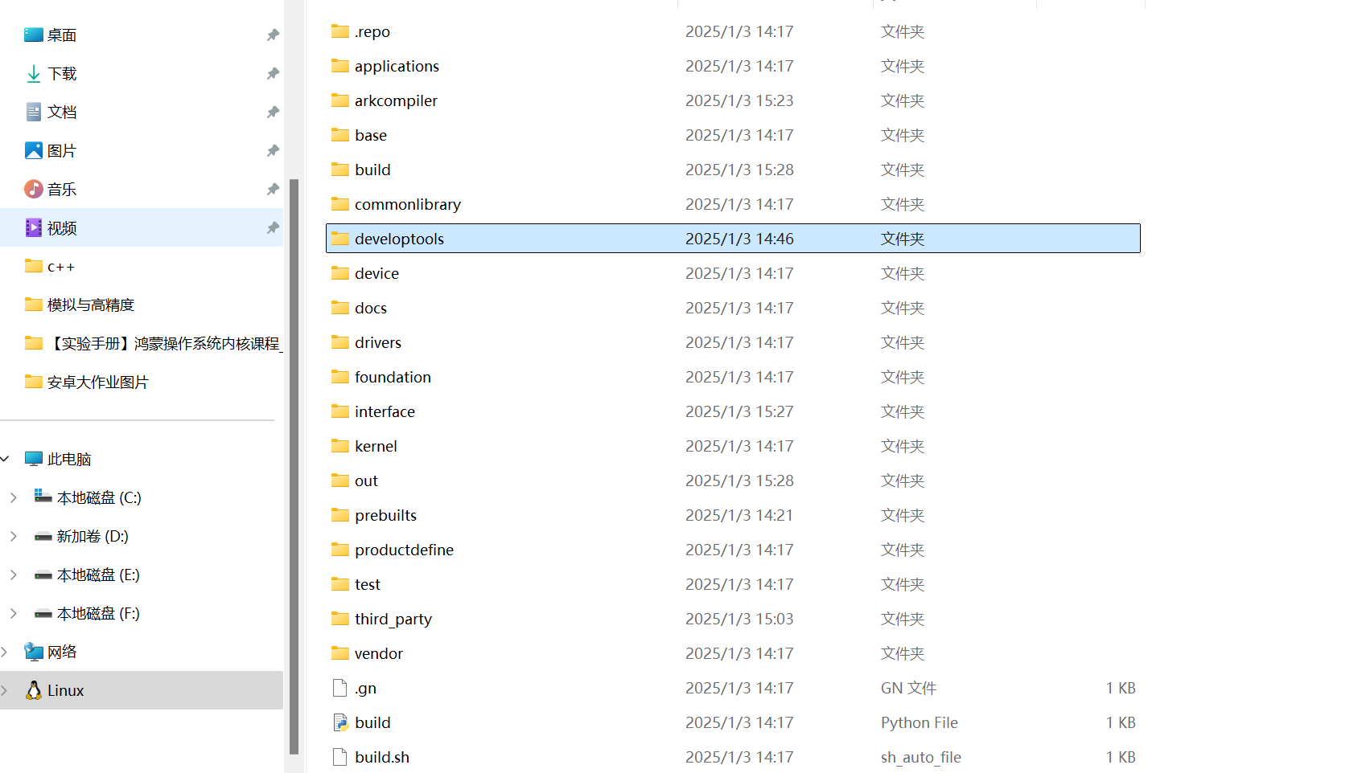
有的话，直接执行下列语句：
（1）. developtools_ace_ets2bundle
cd developtools…
git clone https://gitee.com/openharmony/developtools_ace_ets2bundle.git
cd developtools_ace_ets2bundle/
git checkout -b release_4_1 origin/OpenHarmony-4.1-Release
cd ..
mv developtools_ace_ets2bundle ace_ets2bundle
cd ..
./build/prebuilts_download.sh

（2）. developtools_ace_js2bundle
cd developtools…
git clone https://gitee.com/openharmony/developtools_ace_js2bundle.git
cd developtools_ace_js2bundle/
git checkout -b release_4_1 origin/OpenHarmony-4.1-Release
cd ..
mv developtools_ace_ets2bundle ace_js2bundle
cd ..
./build/prebuilts_download.sh

（3）third_party_jsframework
cd third_party/
git clone https://gitee.com/openharmony/third_party_jsframework.git
cd third_party_jsframework/
git checkout -b release_4_1 origin/OpenHarmony-4.1-Release
cd ..
mv third_party_jsframework jsframework
cd ..
./build/prebuilts_download.sh

（4）third_party_parse5
cd third_party/
git clone https://gitee.com/openharmony/third_party_parse5.git
cd third_party_parse5/
git checkout -b release_4_1 origin/OpenHarmony-4.1-Release
cd ..
mv third_party_parse5 parse5
cd ..
./build/prebuilts_download.sh

（5）third_party_weex-loader
cd third_party/
git clone https://gitee.com/openharmony/third_party_weex-loader.git
cd third_party_weex-loader
git checkout -b release_4_1 origin/OpenHarmony-4.1-Release
cd ..
mv third_party_weex-loader weex-loader
cd ..
./build/prebuilts_download.sh

（6）arkcompiler_ets_frontend 由于arkcompiler文件夹不存在，需要先创建文件夹。

mkdir arkcompiler
cd arkcompiler
git clone https://gitee.com/openharmony/arkcompiler_ets_frontend.git
cd arkcompiler_ets_frontend
git checkout -b release_4_1 origin/OpenHarmony-4.1-Release
cd ..
mv arkcompiler_ets_frontend ets_frontend
cd ..
./build/prebuilts_download.sh

（7）interface_sdk-js，与（5）类似
mkdir interface
cd interface
git clone https://gitee.com/openharmony/interface_sdk-js.git
cd interface_sdk-js
git checkout -b release_4_1 origin/OpenHarmony-4.1-Release
cd ..
mv interface_sdk-js sdk-js
cd ..
./build/prebuilts_download.sh

- 配置riskv交叉编译环境
执行下列语句：
pip install ecdsa -i https://pypi.tuna.tsinghua.edu.cn/simple
pip install scons -i https://pypi.tuna.tsinghua.edu.cn/simple
pip install pycryptodome -i https://pypi.tuna.tsinghua.edu.cn/simple

回到用户主目录
cd ..

执行以下命令：
wget https://repo.huaweicloud.com/harmonyos/compiler/gcc_riscv32/7.3.0/linux/gcc_riscv32-linux-7.3.0.tar.gz

sudo tar -xvf gcc_riscv32-linux-7.3.0.tar.gz -C /opt/

vim ~/.bashrc

打开后页面长这样
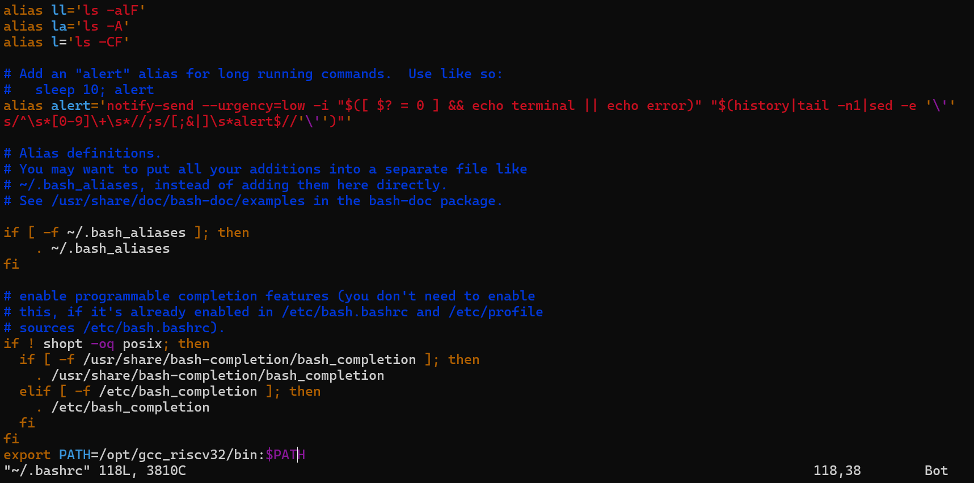
点击i键进入编辑模式，一直按下箭头到最后一行。敲回车键另起一行，粘贴
export PATH=/opt/gcc_riscv32/bin:$PATH
到文件中

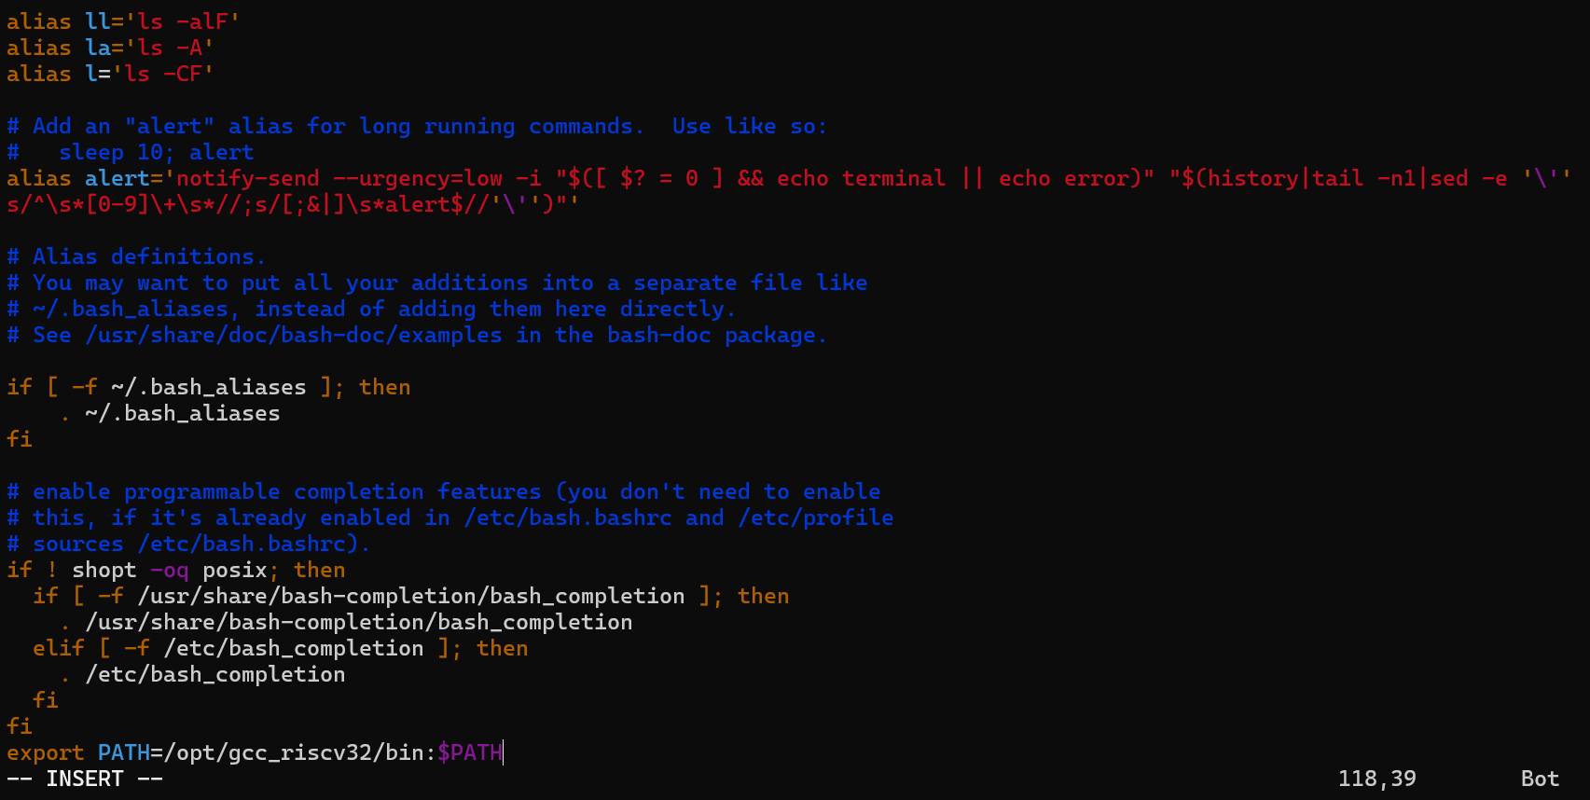

点击Esc键退出编辑模式，按下shift+”:”，输入wq，按下回车，回到命令行。

执行
source ~/.bashrc

riscv32-unknown-elf-gcc -v

结果如图
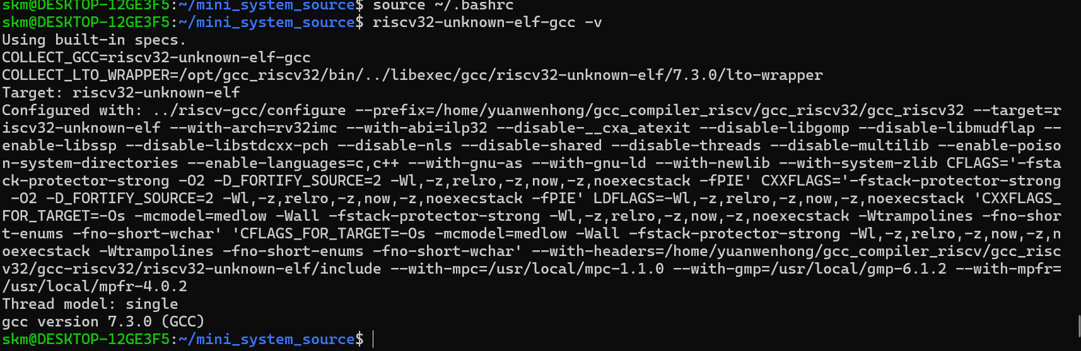

此时回到mini_system_source文件夹
cd ~/mini_system_source

执行./build.sh --product-name wifiiot_hispark_pegasus --ccache --no-prebuilt-sdk
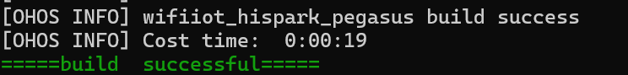
成功编译镜像

